Module-6 Core Java
- Introduction to java
Q.1: History of Java
Ans: Java is an Object-Oriented programming language developed by James Gosling in the early 1990s. The team initiated this project to develop a language for digital devices such as set-top boxes, televisions, etc. Originally, C++ was considered to be used in the project, but the idea was rejected for several reasons(For instance, C++ required more memory). Gosling endeavoured to alter and expand C++; however, before long surrendered that for making another stage called Green. James Gosling and his team called their project “Greentalk” and its file extension was .g,t and later became to known as “OAK”.

- Why “Oak”?
- The name Oak was used by Gosling after an oak tree that remained outside his office. Also, Oak is an image of solidarity and was picked as a national tree of numerous nations like the U.S.A., France, Germany, Romania, etc. But they had to later rename it as JAVA as it was already a trademark by Oak Technologies. “JAVA” Gosling and his team did a brainstorming session, and after the session, they came up with several names such as JAVA, DNA, SILK, RUBY, etc. The name " Java " was decided after much discussion since it was so unique.
- The name Java originates from a sort of espresso bean, Java. Gosling came up with this name while having a coffee near his office. Java was created on principles like Robust, Portable, Platform Independent, High Performance, Multithread, etc., and was called one of the Ten Best Products of 1995 by TIME MAGAZINE. Currently, Java is used in internet programming, mobile devices, games, e-business solutions, etc.
- The java language has experienced a few changes since JDK 1.0, such as various augmentations of classes and packages to the standard library. In Addition to the language changes, considerably more sensational changes have been made to the Java Class Library throughout the years, which has developed from a couple of hundred classes in JDK 1.0 to more than three thousand in J2SE 5.

History of various Java Versions
Versions | Release Date | Major Changes
JDK Beta | 1995
JDK 1.0 | January 1996 | The Very first version was released on January 23, 1996. The principal stable variant, JDK 1.0.2, is called Java 1.
JDK 1.1 | February 1997 | Was released on February 19, 1997. There were many additions in JDK 1.1 as compared to version 1.0 such as  - A broad retooling of the AWT occasion show  - Inner classes added to the language  - JavaBeans  - JDBC  - RMI
J2SE 1.2 | December 1998 | "Play area" was the codename which was given to this form and was released on 8th December 1998. Its real expansion included: strictfp keyword  - the Swing graphical API was coordinated into the centre classes  - Sun's JVM was outfitted with a JIT compiler out of the blue  - Java module  - Java IDL, an IDL usage for CORBA interoperability  - Collections system
J2SE 1.3 | May 2000 | Codename- “KESTREL” Release Date- 8th May 2000 Additions:  - HotSpot JVM included  - Java Naming and Directory Interface  - JPDA  - JavaSound  - Synthetic proxy classes
J2SE 1.4 | February 2002 | Codename- “Merlin” Release Date- 6th February 2002 Additions: Library improvements  - Regular expressions modelled after Perl regular expressions  - The image I/O API for reading and writing images in formats like JPEG and PNG  - Integrated XML parser and XSLT processor (JAXP) (specified in JSR 5 and JSR 63)  - Preferences API (java.util.prefs)  Public Support and security updates for this version ended in October 2008.
J2SE 5.0 | September 2004 | Codename- “Tiger” Release Date- “30th September 2004” Originally numbered as 1.5 which is still used as its internal version. Added several new language features such as:  - for-each loop  - Generics  - Autoboxing  - Var-args
JAVA SE 7 | July 2011 | Codename- “Dolphin” Release Date- 7th July 2011 Added small language changes including strings in the switch. The JVM was extended with support for dynamic languages. Additions:  - Compressed 64-bit pointers.  - Binary Integer Literals.  - Upstream updates to XML and Unicode.
JAVA SE 8 | March 2014 | Released Date- 18th March 2014 Language level support for lambda expressions and default methods and a new date and time API inspired by Joda Time.
JAVA SE 9 | September 2017 | Release Date: 21st September 2017 Project Jigsaw: designing and implementing a standard, a module system for the Java SE platform, and to apply that system to the platform itself and the JDK.
JAVA SE 10 | March 2018 | Released Date- 20th March Addition:  - Additional Unicode language-tag extensions  - Root certificates  - Thread-local handshakes  - Heap allocation on alternative memory devices  - Remove the native-header generation tool – javah.  - Consolidate the JDK forest into a single repository.
JAVA SE 11 | September 2018 | Released Date- 25th September, 2018 Additions-  - Dynamic class-file constants  - Epsilon: a no-op garbage collector  - The local-variable syntax for lambda parameters  - Low-overhead heap profiling  - HTTP client (standard)  - Transport Layer Security (TLS) 1.3  - Flight recorder
JAVA SE 12 | March 2019 | Released Date- 19th March 2019 Additions-  - Shenandoah: A Low-Pause-Time Garbage Collector (Experimental)  - Microbenchmark Suite  - Switch Expressions (Preview)  - JVM Constants API  - One AArch64 Port, Not Two  - Default CDS Archives
JAVA SE 13 | September 2019 | Released Date - 17th September 2019  Additions-  - Text Blocks (Multiline strings).  - Switch Expressions.  - Enhanced Thread-local handshakes.
JAVA SE 14 | March 2020 | Released Date - 17th March 2020  Additions-  - Records (new class type for data modeling).  - Pattern Matching for instanceof.  - Helpful NullPointerExceptions.
JAVA SE 15 | September 2020 | Released Date - 15th September 2020  Additions-  - Sealed Classes.  - Hidden Classes.  - Foreign Function and Memory API (Incubator)
JAVA SE 16 | March 2021 | Released Date - 16th March 2021  Additions-  - Records (preview feature).  - Pattern Matching for switch (preview feature).  - Unix Domain Socket Channel (Incubator).
JAVA SE 17 | September 2021 | Released Date - 14th September 2021  Additions-  - Sealed Classes (finalized).  - Pattern Matching for instanceof (finalized).  - Strong encapsulation of JDK internals by default.  - New macOS rendering pipeline.

Q.2: Features of Java (Platform Independent, Object-Oriented, etc.).
Ans:
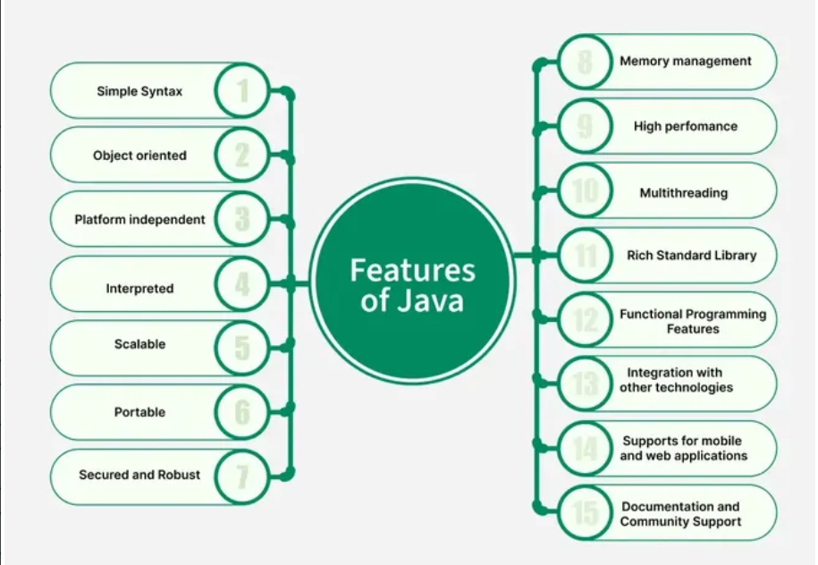
1. Simple Syntax
Java syntax is very straightforward and very easy to learn. Java removes complex features like pointers and multiple inheritance, which makes it a good choice for beginners.
2. Object oriented: -
Java is fully Object-oriented programming language. & Object oriented concepts are following.
• Class
• Object
• Inheritance
• Encapsulation
• Polymorphism
3. Portable
The feature Write-once-run-anywhere makes the java language portable provided that the system must have interpreter for the JVM. Java also having the standard data size irrespective of operating system or the processor. This feature makes the java as a portable language.
4.Distributed
The widely used protocols like HTTP and FTP are developed in java. Internet programmers can call functions on these protocols and can get access the files from any remote machine on the internet rather than writing codes on their local system.
5. High performance
Java uses native code usage, and lightweight process called threads. In the beginning interpretation of bytecode resulted the performance slow but the advance version of JVM uses the adaptive and just in time compilation technique that improves the performance.
6. Multithreaded
As we all know several features of Java like Secure, Robust, Portable, dynamic etc; you will be more delighted to know another feature of Java which is Multithreaded.
Java is also a Multi-threaded programming language. Multithreading means a single program having different threads executing independently at the same time. Multiple threads execute instructions according to the program code in a process or a program. Multithreading works the similar way as multiple processes run on one computer. Multithreading programming is a very interesting concept in Java. In multithreaded programs not even a single thread disturbs the execution of other thread. Threads are obtained from the pool of available ready to run threads and they run on the system CPUs. This is how Multithreading works in Java which you will soon come to know in details in later chapters.
7. Robust
Java has the strong memory allocation and automatic garbage collection mechanism. It provides the powerful exception handling and type checking mechanism as compare to other programming languages. Compiler checks the program whether there any error and interpreter checks any run time error and makes the system secure from crash. All of the above features make the java language robust.
8. Dynamic
While executing the java program the user can get the required files dynamically from a local drive or from a computer thousands of miles away from the user just by connecting with the Internet.
9. Secure
Java does not use memory pointers explicitly. All the programs in java are run under an area known as the sand box. Security manager determines the accessibility options of a class like reading and writing a file to the local disk. Java uses the public key encryption system to allow the java applications to transmit over the internet in the secure encrypted form. The bytecode Verifier checks the classes after loading.
10. Platform Independent
Java code runs on any operating system (Windows, Linux, Mac) due to:
Write Once, Run Anywhere (WORA)
Java uses JVM (Java Virtual Machine) → makes bytecode platform independent.

11.Architecture Neutral
Java bytecode is architecture-neutral and not dependent on the machine's hardware.
Q.3: Understanding JVM, JRE, and JDK
Ans:
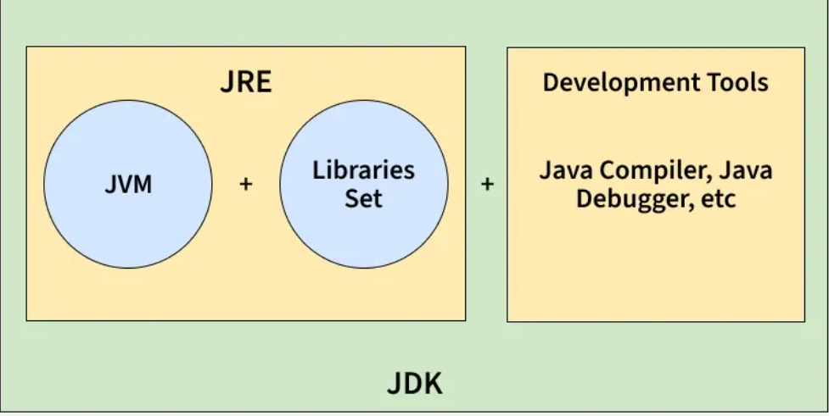
JDK (Java Development Kit)
The JDK is a software development kit used to build Java applications. It contains the JRE and a set of development tools.
- Includes compiler (javac), debugger, and utilities like jar and javadoc.
- Provides the JRE, so it also allows running Java programs.
- Required by developers to write, compile, and debug code.
Components of JDK:
- JRE (JVM + libraries)
- Development tools (compiler, jar, javadoc, debugger)
Note:
- JDK is only for development (it is not needed for running Java programs)
- JDK is platform-dependent (different version for windows, Linux, macOS)

Working of JDK:
- Source Code (.java): Developer writes a Java program.
- Compilation: The JDK’s compiler (javac) converts the code into bytecode stored in .class files.
- Execution: The JVM executes the bytecode, translating it into native instructions.

JRE (Java Runtime Environment)
The JRE provides an environment to run Java programs but does not include development tools. It is intended for end-users who only need to execute applications.
- Contains the JVM and standard class libraries.
- Provides all runtime requirements for Java applications.
- Does not support compilation or debugging.
Note:
- JRE is only for running applications, not for developing them.
- It is platform-dependent (different builds for different OS).
Working of JRE:
- Class Loading: Loads compiled .class files into memory.
- Bytecode Verification: Ensures security and validity of bytecode.
- Execution: Uses the JVM (interpreter + JIT compiler) to execute instructions and make system calls.

JVM (Java Virtual Machine)
The JVM is the core execution engine of Java. It is responsible for converting bytecode into machine-specific instructions.
- Part of both JDK and JRE.
- Performs memory management and garbage collection.
- Provides portability by executing the same bytecode on different platforms.
Note:
- JVM implementations are platform-dependent.
- Bytecode is platform-independent and can run on any JVM.
- Modern JVMs rely heavily on Just-In-Time (JIT) compilation for performance.

Working of JVM:
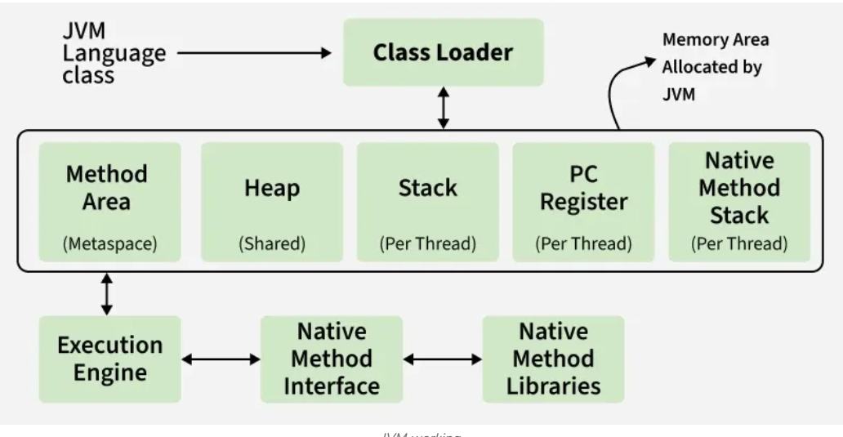
- Loading: Class loader loads bytecode into memory.
- Linking: Performs verification, preparation, and resolution.
- Initialization: Executes class constructors and static initializers.
- Execution: Interprets or compiles bytecode into native code.

JDK vs JRE vs JVM
Aspect | JDK | JRE | JVM
Purpose | Used to develop Java applications | Used to run Java applications | Executes Java bytecode
Platform Dependency | Platform-dependent (OS specific) | Platform-dependent (OS specific) | JVM is OS-specific, but bytecode is platform-independent
Includes | JRE + Development tools (javac, debugger, etc.) | JVM + Libraries (e.g., rt.jar) | ClassLoader, JIT Compiler, Garbage Collector
Use Case | Writing and compiling Java code | Running a Java application on a system | Convert bytecode into native machine code

Q.4: Setting up the Java environment and IDE (e.g., Eclipse, IntelliJ)
Ans:
1. Install Java Development Kit (JDK)
Step 1: Download JDK
Go to Oracle JDK download page
Search → “Download JDK”
Choose your OS (Windows / Mac / Linux)
Step 2: Install JDK
Click the installer → Next → Next → Finish.
Step 3: Set JAVA_HOME (Windows)
- Right-click This PC → Properties
- Click Advanced system settings
- Click Environment Variables
- Under System Variables, click New
  - Variable name: JAVA_HOME
  - Variable value: C:\Program Files\Java\jdk-XX
- Select Path → Edit → Add
%JAVA_HOME%\bin
2. Check Java Installation
Open Command Prompt and type:
java -version
javac -version
If they show version numbers ----Java Installed Successfully!
3. Install an IDE for Java
You can choose Eclipse or IntelliJ IDEA (both are good).
A. Install Eclipse IDE
Step 1: Download
Search: “Eclipse IDE for Java Developers”
Step 2: Install
- Run installer
- Select Eclipse IDE for Java Developers
- Choose installation folder
- Click Launch
Step 3: Create First Java Project
- File → New → Java Project
- Give project name
- Create package → class → write code
- Run using Ctrl + F11
Eclipse is beginner-friendly and widely used in universities.
B. Install IntelliJ IDEA
Step 1: Download
Go to JetBrains IntelliJ IDEA → Choose Community Edition (Free)
Step 2: Install
Click Next → Next → Install.
Step 3: Create First Project
- Open IntelliJ
- New Project
- Select Java
- Choose JDK path
- Create class
- Run → Shift + F10
IntelliJ has the best auto-suggestions and modern UI.
Q.5: Java Program Structure (Packages, Classes, Methods)
Ans: A basic Java program is made of:
- Package
- Class
- Main Method
- Variables / Methods
- Statements
1. Package
A package is a folder that groups related classes.
Syntax:
package packagename;
Example:
package myapp;
Packages help in:
- Organizing code
- Avoiding name conflicts
- Reusability
2. Classes
Everything in Java is inside a class.
Syntax:
class ClassName {
// variables
// methods
}
Example:
class Student {
String name; // variable
int age;

void display() { // method
System.out.println(name + " " + age);
}
}
3. Methods
A method performs some action (function of class).
Syntax:
returnType methodName(parameters) {
// code
}
Example:
void show() {
System.out.println("Hello");

- Data Types, variables, and Operators:-

Q.1: Primitive Data Types in Java (int, float, char, etc.)
Ans: The primitive data types are predefined data types, which always hold the value of the same data type, and the values of a primitive data type don't share the state with other primitive values. These data types are named by a reserved keyword in Java programming language. There are eight primitive data types supported by Java programming language:
- byte
The byte data type is an 8-bit signed two's complement integer. It ranges from -128 to127 (inclusive). This type of data type is useful to save memory in large arrays. We can also use byte instead of int to increase the limit of the code. The syntax of declaring a byte type variable is shown as: byte b = 5;

- short
The short data type is a 16-bit signed two's complement integer. It ranges from -32,768 to 32,767.short is used to save memory in large arrays. The syntax of declaring a short type variable is shown as: short s = 2;

- int
The int data type is used to store the integer values not the fraction values. It is a 32-bit signed two's complement integer data type. It ranges from -2,147,483,648 to 2,147,483,647 that are more enough to store large number in your program. However for wider range of values use long. The syntax of declaring an int type variable is shown as: int n = 50;

- long
The long data type is a 64-bit signed two's complement integer. It ranges from 9,223,372,036,854,775,808 to 9,223,372,036,854,775,807. Use this data type with larger range of values. The syntax of declaring a long type variable is shown as: long ln = 746L;

- float
The float data type is a single-precision 32-bit IEEE 754 floating point. It ranges from 1.40129846432481707e-45 to 3.40282346638528860e+38 (positive or negative). Use a float (instead of double) to save memory in large arrays. We do not use this data type for the exact values such as currency. For that we have to use java.math.BigDecimal class. The syntax of declaring a float type variable is: float f = 105.65f;

- double
This data type is a double-precision 64-bit IEEE 754 floating point. It ranges from 4.94065645841246544e-324d to 1.79769313486231570e+308d (positive or negative). This data type is generally the default choice for decimal values. The syntax of declaring a double type variable is shown as: double d = 6677.60;

- char
The char data type is a single 16-bit, unsigned Unicode character. It ranges from 0 to 65,535. They are not integral data type like int, short etc. i.e. the char data type can't hold the numeric values. The syntax of declaring a char type variable is shown as: char c = ’c’;

- boolean
The boolean data type represents only two values: true and false and occupy is 1-bit in the memory. These values are keywords in Java and represent the two boolean states: on or off, yes or no. We use boolean data type for specifying conditional statements as if, while, do, for. In Java, true and false are not the same as True and False. They are defined constants of the language. The syntax of declaring a boolean type variable is shown as: boolean r = true;

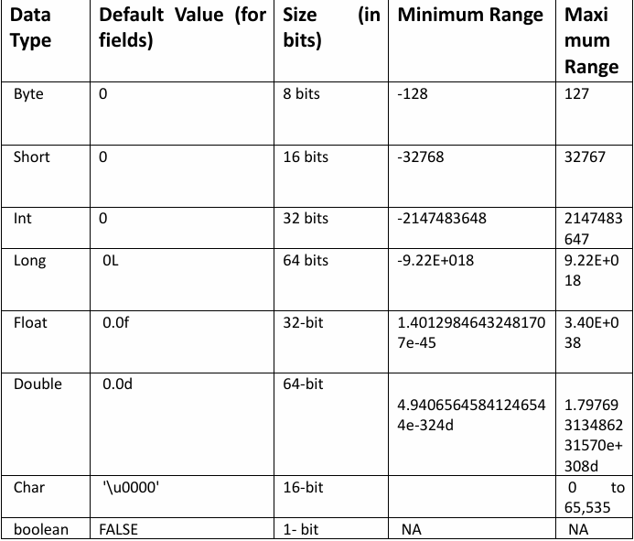

Q.2: Variable Declaration and Initialization
Ans:
- What is a Variable?
A variable is a name given to a memory location that stores a value.

- Variable Declaration
Declaring a variable means reserving memory for it.
Syntax:
dataType variableName;
Example:
int num;
float price;
char grade;
Here, memory is allocated but no value is assigned yet.
- Variable initialization
Initialization means assigning a value to a variable.
Syntax:
variableName = value;
Example:
num = 10;
price = 99.5f;
grade = 'A';

- Declaration + Initialization (Together)
You can do both in one line:
Example:
int a = 10;
float f = 12.5f;
boolean flag = true;
This is most commonly used.
4. Multiple Variable Declaration
You can declare many variables of the same type:
int x, y, z;
x = 10;
y = 20;
z = 30;
Or both together:
int x = 10, y = 20, z = 30;

Q.2: Operators: Arithmetic, Relational, Logical, Assignment, Unary, and Bitwise
Ans:
  - Arithmetic:
Used for mathematical calculations.
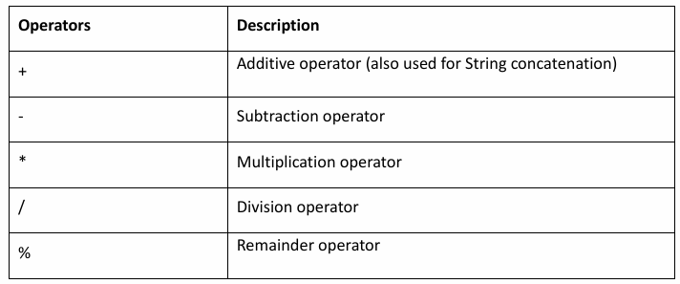
Example:
class ArithmeticOperator
{
public void Addition(int a, int b)
{
System.out.println("Ans is:-"+(a+b));
}
public void Subtract(int a, int b)
{
System.out.println("Ans is:-"+(a-b));
}
public void Multiply(int a, int b)
{
System.out.println("Ans is:-"+(a*b));
}
public void Divide(int a, int b)
{
System.out.println("Ans is:-"+(a/b));
}
public static void main(String args[])
{
ArithmeticOperator a1=new ArithmeticOperator();
a1.Addtion(10,20);
a1.Subtract(20,10);
a1.Miltiply(10,10);
a1.Divide(10,2);
}
}
  - Relational:
Used to compare two values.
Return type = boolean (true/false)
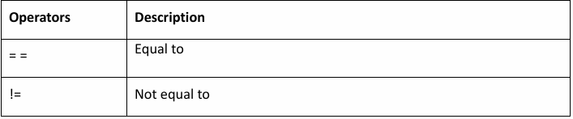
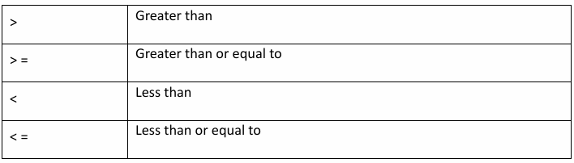
class RelationalOperator
{
public void Equal(int val1,int val2)
{
if(val1 == val2)
{
System.out.println("both are equal");
}
if(val1!=val2)
{
System.out.println("both are not equal");
}
if(val1 val2)
{
System.out.println(val1+" is greater then "s+ val2);
}
}
public static void main(String arg[])
{
RelationalOperator ro = new RelationalOperator();
ro.Equal(10,20);
}
}

  - Logical:
Logical operators are used to perform logical "AND", "OR", and "NOT" operations, i.e., the functions similar to AND gate and OR gate in digital electronics. They are used to combine two or more conditions/constraints or to complement the evaluation of the original condition under particular consideration. One thing to keep in mind is that, while using the AND operator, the second condition is not evaluated if the first one is false. While using the OR operator, the second condition is not evaluated if the first one is true, i.e., the AND and OR operators have a short-circuiting effect. Used extensively to test for several conditions for making a decision.
- AND Operator (&&): If( a && b ) [if true execute else don't]
- OR Operator (||): If( a || b) [if one of them is true to execute; else don't]
- NOT Operator (!): !(a<b) [returns false if a is smaller than b]

  - Assignment:

Used to assign values to variables.

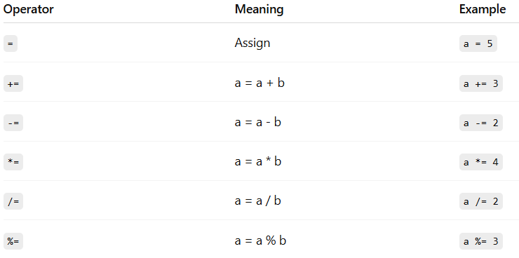

  - Unary:
Unary = one operand.
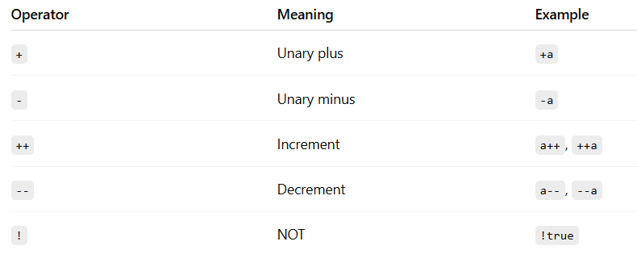
  - Bitwise:
Used to perform operations on bits (binary numbers).
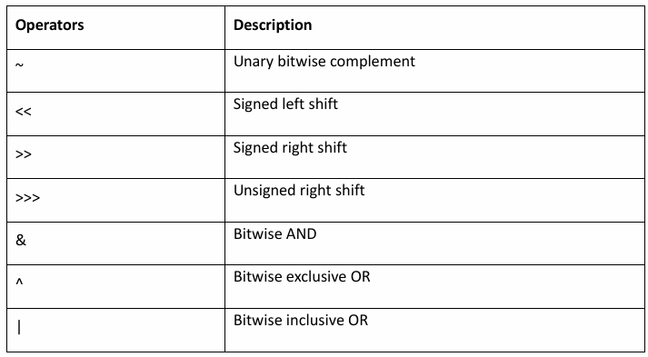

  - Unary:
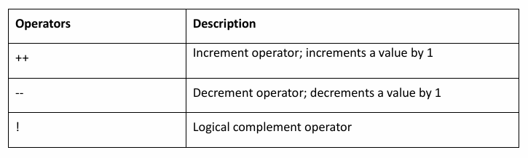
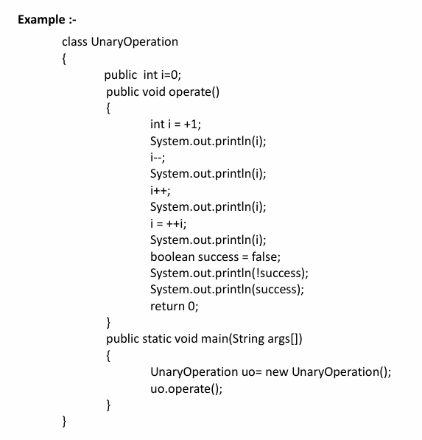

Q.4: Type Conversion and Type Casting
Ans: Java allows you to convert one data type into another.
There are two types:
- Type Conversion (Widening / Automatic)
- Type Casting (Narrowing / Manual)
1. Type Conversion (Widening / Automatic)
- Happens automatically
- No data loss
- Smaller type → Larger type
Order of widening:
Example:
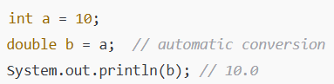
Here int automatically converted to double.
2. Type Casting (Narrowing / Manual)
- Happens manually
- Data loss may happen
- Larger type → Smaller type
- Requires casting operator (type)
Example:
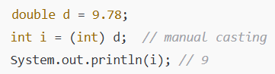
Decimal part is lost → Data Loss.
Widening vs Narrowing Table
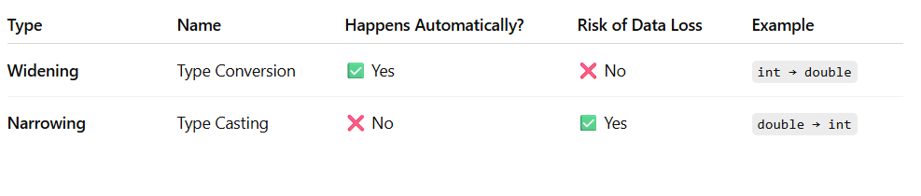

- Control Flow Statements-

Q.1: If-Else Statements
Ans:
The "if-else" statement is an extension of if statement that provides another option when 'if' statement evaluates to "false" i.e. else block is executed. if "if" statement is false.
The if–else statement is used in Java to make decisions in a program.
It allows your program to execute different code depending on a condition.
Syntax:
if (condition) {
// runs if condition is true
// statement_or_block1
} else {
// runs if condition is false
// statement_or_block2
}
If the condition is true, then statement_or_block1 is executed. Otherwise, statement_or_block2 (if it exists) is executed. In no case will both statements be executed.
Example:
if (x < 10)
{
System.out.println("Are you finished yet?");
}
else {
System.out.println("Keep working...");
}
Q.2: Switch Case Statements
Ans:
Switch Statements This is an easier implementation to the if-else statements. The keyword "switch" is followed by an expression that should evaluates to byte, short, char or int primitive data types, only. In a switch block there can be one or more labeled cases. The expression that creates labels for the case must be unique. The switch expression is matched with each case label. Only the matched case is executed, if no case matches then the default statement (if present) is executed.
The switch statement is Java’s multi-way branch statement. It provides an easy way to dispatch execution to different parts of your code based on the value of an expression.
Syntax:
switch(expression) {
case value1:
// code for value1
break;
case value2:
// code for value2
break;
case value3:
// code for value3
break;
default:
// code when no case matches
}
Example:
int day = 3;
switch(day) {
case 1:
System.out.println("Monday");
break;
case 2:
System.out.println("Tuesday");
break;
case 3:
System.out.println("Wednesday");
break;
default:
System.out.println("Invalid day");
}
Q.3: Loops (For, While, Do-While)
Ans:
A loop is used to repeat a block of code multiple times.
Java has three types of basic loops:
- for loop
- while loop
- do-while loop

  - For:
    - When do we use it?
We use a for loop when we know exactly how many times the loop should run.
- Syntax:
for(initialization; condition; update) {
// statements
}
- Example: Print numbers from 1 to 5
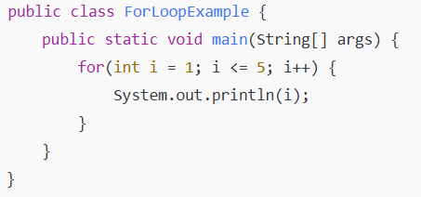
  - While:
- When do we use it?
We use a while loop when we do not know how many times the loop should run.
The loop continues as long as the condition is true.
- Syntax:
while(condition) {
// statements
}
- Example: Print numbers from 1 to 5
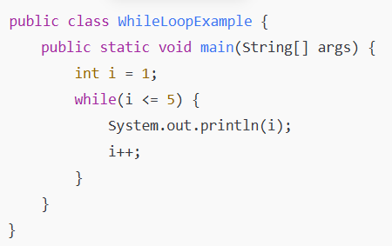
  - Do-While Loop:
- When do we use it?
We use a do-while loop when we want the loop body to run at least one time, even if the condition is false.
- Syntax:
do {
// statements
} while(condition);
- Example:
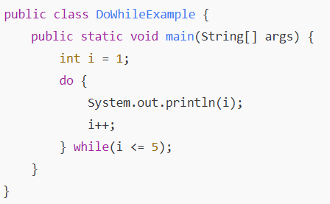
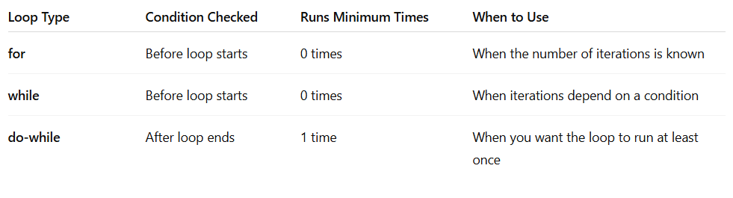
Q.4: Break and Continue Keywords.
Ans: Java provides two important jump statements: break and continue. These are used inside loops (for, while, do-while) to control how the loop behaves.
- Break Keyword:
- Purpose:
The break statement is used to immediately exit a loop.
When break is executed, the loop stops completely, and control moves to the next statement after the
- Example: Stop the loop when i becomes 3
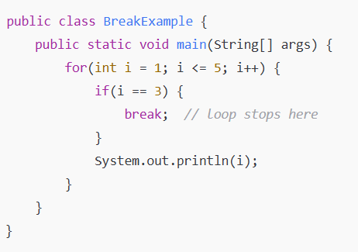
- Output:
1
2
- Continue Keyword:
- Purpose:
The continue statement is used to skip the current iteration of the loop.
The loop does not stop — it just jumps to the next iteration.
- Example: Skip Printing number 3:
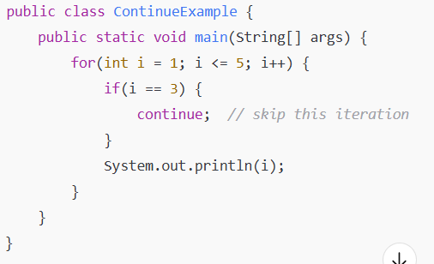
- Output:
1
2
3
4
`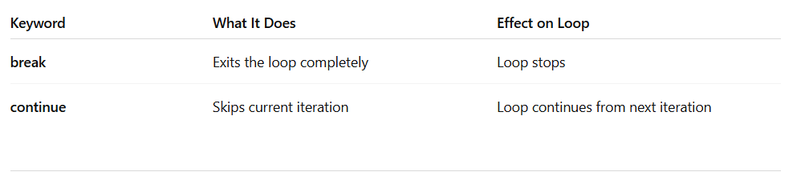

- Classes and Objects-
Q.1: Defining Classes and Objects in java
Ans:
  - Class
A class is a blueprint or prototype from which objects are created.
This section defines a class that models the state and behavior of a real-world object.
It intentionally focuses on the basics, showing how even simple classes can cleanly model state and behavior.
In the real world, you'll often find many individual objects all of the same kind. here may be thousands of other bicycles in existence, all of the same make and model.
Each bicycle was built from the same set of blueprints and therefore contains the same components. In object-oriented terms, we say that your bicycle is an instance of the class of objects known as bicycles.
A class is the blueprint from which individual objects are created.
Syntax:
<modifier>* class <classname>{
<Attribute_declaration>*
<constructor_Declaration>*
<method_declaration>*
}
Example:
public class Vehicle {
private double maxLoad;
public void setMaxLoad (double value) {
maxLoad = value;
}
}
  - Object:
An object is a instance of class. We can also say that object is blue print of the class .
Syntax:
Classname objectname = new classname();
Here:
- ClassName → name of the class
- obj → object reference
- new → creates memory for the object
Example:
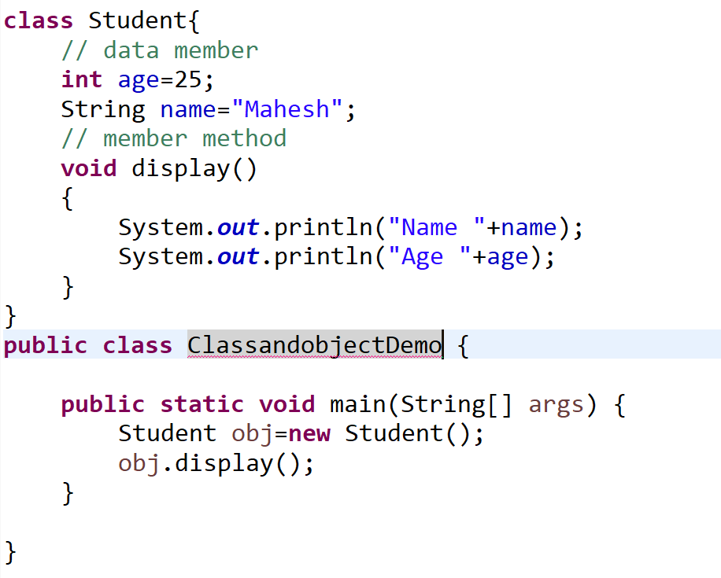
Q.2: Constructors and Overloading
Ans:
- Constructor:
In Java, a constructor is a special method that is used to initialize objects.
When an object is created, the constructor runs automatically.
A constructor is a block of code inside a class that:
- Has the same name as the class
- Does not have any return type (not even void)
- Runs automatically when an object is created
Syntax:
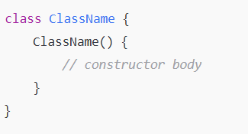
Purpose:
To initialize object values.
Types of Constructors in Java
      - Default Constructor:
1.There is always at least one constructor in every class.
2. If the writer does not supply any constructors, the default constructor is present automatically:
3. The default constructor takes no arguments
4. The default constructor body is empty
5. The default enables you to create object instances with new Xxx()without having to write a constructor.
6. Created automatically by Java when no constructor is written.
Example:
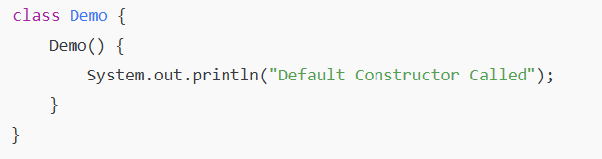
      - Parameterized Constructor:
        - A constructor that accepts parameters.
Example:
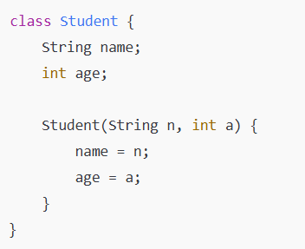

- Constructor Overloading:
A class having more than one constructor with different parameters.
Rules:
- Same constructor name (same as class name)
- Different number or type of parameters
Example:
class Student {
String name;
int age;

// Default constructor
Student() {
name = "Unknown";
age = 0;
}

// Parameterized constructor with 1 parameter
Student(String n) {
name = n;
age = 18; // default age
}

// Parameterized constructor with 2 parameters
Student(String n, int a) {
name = n;
age = a;
}

void display() {
System.out.println("Name: " + name + ", Age: " + age);
}
}

public class Main {
public static void main(String[] args) {

Student s1 = new Student();
Student s2 = new Student("John");
Student s3 = new Student("Alice", 22);

s1.display();
s2.display();
s3.display();
}
}
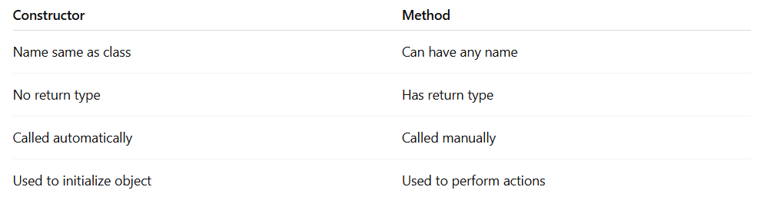
Q.3: Object Creation, Accessing Members of the Class.
Ans:
- Object Creation
Syntax:
ClassName objectName = new ClassName();
Explanation:
- ClassName → name of the class
- objectName → reference variable
- new → creates memory
- ClassName() → constructor call
Example:
Student s1 = new Student();
This line creates an object named s1 of the class Student.
- Accessing Members of the Class:
A class contains:
- Data Members (Variables)
- Member Methods (Functions)
We use dot ( . ) operator to access them through an object.
Syntax:
objectName.variableName;
objectName.methodName();
Example: Object Creation + Accessing Members
class Student {
// data members
String name;
int age;

// method
void display() {
System.out.println("Name: " + name);
System.out.println("Age: " + age);
}
}

public class Main {
public static void main(String[] args) {
// object creation
Student s1 = new Student();

// accessing members
s1.name = "John";
s1.age = 21;

// calling method
s1.display();
}
}

Q.4: this Keyword
Ans: this keyword refers to the current class reference.
It is used inside class methods and constructors.
Here are three main uses of this keyword:
• To resolve ambiguity between instance variable and parameter.
• To pass current object as a parameter to another method or constructor.
• To call a constructor from another constructor of same class.
Example:
class Student {
String name; // instance variable
Student(String name) { // local variable
this.name = name; // this.name → instance variable
}
void display() {
System.out.println("Name: " + this.name);
}
}

- Methods in java-
Q.1: Defining Methods
Ans: A method in Java is a block of code that performs a specific task.
Methods help make code reusable, organized, and easy to understand.
A method runs only when it is called.
  - Syntax for Defining a Method:
returnType methodName(parameters) {
// method body (statements)
}
Parts of a Method:
- returnType → Type of value the method returns (int, void, String, etc.)
- methodName → Name of the method
- parameters → (Optional) Input values
- method body → Code to be executed
  - Example
class Demo {

// method definition
void display() {
System.out.println("This is a method in Java.");
}
}
Q.2: Method Parameters and Return Types
Ans:
In Java, methods often need input values and sometimes need to send
back a result.
This is where parameters and return types are used.
What are Parameters?
Parameters are values passed into a method so that the method can use them.
They work like local variables inside the method.
Syntax:
returnType methodName(type param1, type param2) {
// use param1 & param2
}
Example:
void greet(String name) {
System.out.println("Hello, " + name);
}
Calling method:
greet("John");
Return Types:
- What is a Return Type?
The return type specifies what value the method will return.
- If a method returns nothing → return type is void
- If it returns a number → int, double, etc.
- If it returns text → String
- If it returns an object → use the class name
- Syntax:
returnType methodName(parameters) {
return value;
}
- Example:
  - Method returning an integer
int add(int a, int b) {
return a + b;
}
Calling:
int result = add(5, 10);
  - Returning String
String getMessage() {
return "Welcome to Java!";
}
Calling:
String msg = getMessage();
  - Void method
void display() {
System.out.println("This is a void method.");
}
Q.3: Method Overloading
Ans: Method Overloading means having multiple methods in the same class with:
- Same method name
- Different parameters
(Parameters must differ in number, type, or order)
It is a type of Compile-Time Polymorphism.
Why Use Method Overloading?
- To improve code readability
- To perform similar tasks with different inputs
- To avoid creating multiple method names for similar operations
Example:
class Calculator {

// method with 2 parameters
int add(int a, int b) {
return a + b;
}

// overloaded method with 3 parameters
int add(int a, int b, int c) {
return a + b + c;
}

// overloaded method with different types
double add(double a, double b) {
return a + b;
}
}

public class Main {
public static void main(String[] args) {

Calculator c = new Calculator();

System.out.println(c.add(10, 20)); // 2 ints
System.out.println(c.add(10, 20, 30)); // 3 ints
System.out.println(c.add(5.5, 2.5)); // doubles
}
}
Key Point:
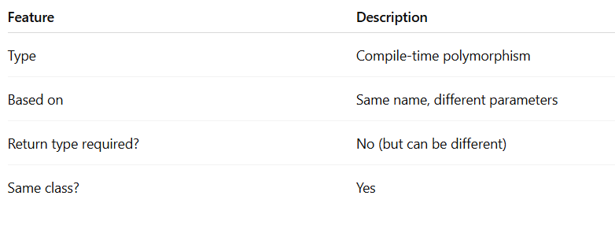

Q.4: Static Methods and Variables
Ans: In Java, the keyword static is used to create class-level members.
This means the member belongs to the class, not to any specific object.
- Static Keyword:
There will be times when you will want to define a class member that will be used independently of any object of that class.
Normally a class member must be accessed only in conjunction with an object of its class. However, it is possible to create a member that can be used by itself, without reference to a specific instance.
To create such a member, precede its declaration with the keyword static. When a member is declared static, it can be accessed before any objects of its class are created, and without reference to any object.
You can declare both methods and variables to be static. The most common example of a static member is main( ). main( ) is declared as static because it must be called before any objects exist.
Instance variables declared as static are, essentially, global variables. When objects of its class are declared, no copy of a static variable is made. Instead, all instances of the class share the same static variable.
1. Static Variables:
A static variable is shared by all objects of the class.
- Created only once in memory
- Shared by all instances
- Accessed using class name
Syntax:
static dataType variableName;
2. Static Method:
A static method can be called without creating an object.
- Belongs to the class
- Can access only static variables directly
- Cannot access non-static (instance) variables
Methods declared as static have several restrictions:
They can only call other static methods.
They must only access static data.
They cannot refer to this or super in any way.
Syntax:
static returnType methodName() {
// code
}
Example:
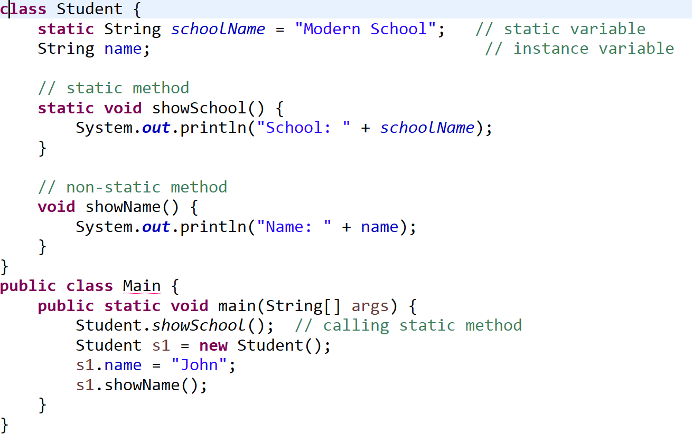

- Object-Oriented Programming-
Q.1: Basics of OOP: Encapsulation, Inheritance, Polymorphism, Abstraction
Ans:
1. Encapsulation
Definition:
Wrapping (encapsulating) data (variables) and methods (functions) into a single unit (class) + protecting the data using access modifiers (private, public, etc.)
Why use it?
- Protect Data
- Control access
- Improves security
Example:
class Student {
private String name; // private = hidden from outside

public void setName(String name) { // setter
this.name = name;
}

public String getName() { // getter
return name;
}
}

public class Test {
public static void main(String[] args) {
Student s = new Student();
s.setName("Mahesh");
System.out.println(s.getName());
}
}

2. inheritance:
Definition:
One class (child) acquiring the properties/methods of another class (parent).
Why use it?
- Code reusability
- Method overriding suppot

Example:
class Animal {
void eat() {
System.out.println("Eating...");
}
}

class Dog extends Animal {
void bark() {
System.out.println("Barking...");
}
}

public class Test {
public static void main(String[] args) {
Dog d = new Dog();
d.eat(); // from parent
d.bark(); // from child
}
}
3. Polymorphism:
Polymorphism is the ability of an object to take multiple forms, allowing the same method to behave differently depending on the situation.

